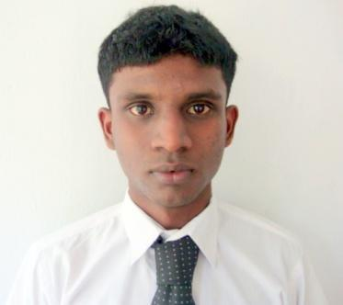

***Mr. S. D. Fernando***

***No: 225,Uswatta,***

***Delathura,***

***JaEla,***

***Sri Lanka.***

***Contact No: 011-2240812, 077-4316051***

***E-mail :***[***shenaldushantha@gmail.com***](mailto:shenaldushantha@gmail.com)

**CAREER OBJECTIVE:**

**I always look forward to a working environment that is creatively stimulating and provides me ample opportunity to test my physical and mental capabilities. Along with it I should be able to co-relate personal values of my sincerely and integrity to my work.**

**EXPERIENCE**

* **Worked as an IT Executive at THE INTEROCEAN MARITIME ENTERPRISES (PVT) LTD since September 2013 to June 2014.**
* **Presently I’m working as an IT Executive at MOHKSHA (PVT) LTD (STONE-N-STRING) since July 2014.**

**PROFESSIONAL QUALIFICATION**

* **Diploma in English Language from American College of higher education Sri Lanka.**
* **Diploma in Spoken English Language, grammar from British Council Sri Lanka.**
* **Completed Higher Diploma in Computer Science in Infortec International computer Institute at Gampaha branch.**

**(2012 October – 2013 September)**

* **Presently I’m following the Bachelor of Information Technology (External) at University of Colombo (University of Colombo School of Computing).**

**(2014/2015 1st year)**

**OTHER QUALIFICATION**

* **Participated in national competitions in Karatedo.**
* **Participated in international competitions for School in English Language.**
* **Passed Catholic Daham Pasal Final Certificate Examination with four Distinction passes in 2009.**

**TRAINING PROGRAMS**

* **Certified as enthusiastic and well-performed in Personal Development Camp holden at Folk Art Theatre.**

**PERSONAL PROFILE**

* **Name in full : Madanakondage Shenal Dushantha Fernando**
* **Date of birth : 1992-03-27**
* **Age : 23 years**
* **NIC : 920872778 V**
* **Marital status : Single**
* **Sex : Male**
* **Civil State : Single**
* **Nationality : SriLankan**
* **Religion : Roman Catholic**
* **Driving Licence No. & Class : B1511731 A1,A,B1,B,G1**
* **Residential District : Gampaha**
* **Residential Secretariat : Wattala**
* **Permanent Residential Province : Western**
* **Grama Niladari & No. : Delathura West 193**

**ACADEMIC QUALIFICATIONS**

**Ordinary Level Examination**

**Year : 2008**

**School Attend : De Mazenod College**

**Index Number : 80511392**

**Subject Grade**

**Religion A**

**Sinhala Language & Literature A**

**Science A**

**Health Science A**

**History A**

**Mathematics B**

**English B**

**Commerce B**

**Dancing B**

**Advanced Level Examination**

**Year : 2011**

**School Attend : De Mazenod College**

**Index Number : 1300989**

**Subject Grade**

**Combined Mathematics S**

**Physics S**

**Chemistry S**

**Gen: English C**

**G. I. T. C**

**REFEREES**

**Chamaka Perera**

**Director**

**BROADWY SHIPPING SERVICES (PVT) LTD  
No. 136**

**2nd Floor**

**Kumaran Rathnam Road**

**Colombo 02**

**T. P. 0772907272**

**Fazal M. Hashim**

**Manager - Corporate**

**STONE ‘N’ STRING (PVT) LTD**

**275**

**R. A. De Mel Mawatha**

**Colombo - 03.**

**T. P. 0773074386**

**I here by certify that the above particulars are true & accurate to the best of my knowledge & belief.**

**M. S. D. Fernando 21-09-2015**